Requirements

* L5 Accounting is the name of the company
* Create a website
* Create a database

ex:

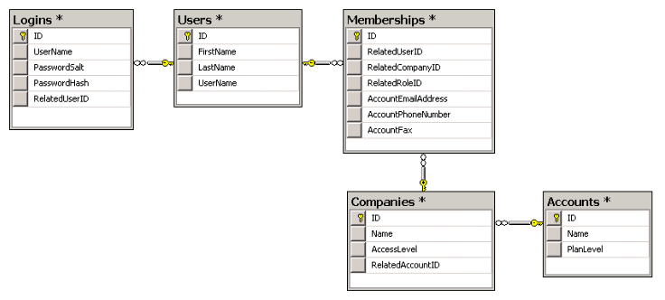

* Create a login system (Username & password)

ex:

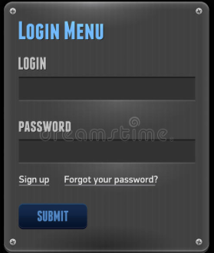

* Create a bank account using UML diagrams firs
* One account for sales and one esco account for sales tax collected per state.
* Track the amount of sales in the ‘Sales Account’ and the amount of sales taxes in the ‘Esco Account’ for every client depending on the sale point
* Send or display a monthly statement to the client account of the amount of sales taxes they owe to each state and their gross
* Five different point of sales (New York, Boston, New Jersey, Connecticut, Chicago)
* Five different clients (Food Truck[4], Luggage Company, Bread Company, Slider Sandwich, Battery)
* Owner of the company releases the tax money to the state
* Date of each transaction
* Send electronic receipts to the website owner
* Yearly tax report for the clients
* owner wants to login and have a record of all transaction(the amount of tax)
* we get a csv file from clients
* ability to send money to esco account directly
* 7 days to fix report(if clients write the wrong income)
* food truck (connecticut, new york, new jersey)
* pdf file to send to clients

**What we each know**

Stanley -> Java, HTML, CSS, JavaScript, Android

Duvall -> Java, Python, C++, HTML, CSS, SQL  
 Starlyn -> Java, C++, SQL, Android, Swift  
 Ziaul (Zia) -> Java, Python, Android, Swift  
 Junior -> Java, Android, Swift

**Questions to ask for wednesday**

1. Where are my client sales point specifically?
2. How are we gonna receive the data?
3. What are the accounting features that you want?

**NOTES FOR PRESENTATION**

blackboard instructions for the presentation:

Please remember that I would like to see part of the presentation blocked off pertaining to the course itself. In other words:

* Describe the company (L5 Accounting)
* List the team members
* List the roles
* Explain you team logistics
  + How you communicate (Email/Phone/SMS, etc.)
  + We’re do you store materials
  + How to you manage task scheduling
* How do you resolve conflicts
* State the Software Engineering group we gather
* State the requirements we have gather
* State the way we analyse the requirements
* State what we are going to use for the implementation
* State the solution
* Chart about who is doing what in the project
* Graph for the Budget
* Portability
* Reliability
* What model are we using
* The process of how the Business works
* Current Status of the software
* Dashboard ?
* Teach the client how our software is looking? Training them
* What is L5 Accounting
* State the problem
* State ]the solution

Add to Github

* The interview
* The recorded
* Documentation